# *Web Programming II (420-C20-HR)*

# *Lab 1 – Set Up and Review*

Date assigned: Monday, January 18, 2016

Date due: **Monday, January 18, 2016, before the end of lab**

**Learning Objectives**

Upon successful completion of this lab exercise, the student will have:

* Set up home drive, email and your Calendar
* Reviewed HTML, CSS for Forms and Responsive Web Design

To do:

**Part A – Set Up Course Folders**

1. On to the network and select Documents from the Start menu or click the Documents icon on the taskbar. This will open your home drive documents folder (your H drive).
2. Click New Folder on the menu bar.
3. Replace the words New Folder with 420-C20.
4. Repeat steps 3 and 4 for 420-A32, 420-B20 and 420-E01.
5. Double-click on 420-C20. Create two new folders here – call one Labs and the other one Assignments.
6. Repeat step 5 for folders 420-A32, 420-B20 and 420-E01.

**Part B - Microsoft® Outlook Set Up**

1. You will usually access your college email using webmail. There is another way to access your College e-mail using Microsoft Outlook. Start Microsoft Outlook 2010 by selecting **Start, Programs, All Programs, Microsoft Office 2013, Outlook 2013** The Outlook Startup window will open. Click Next.

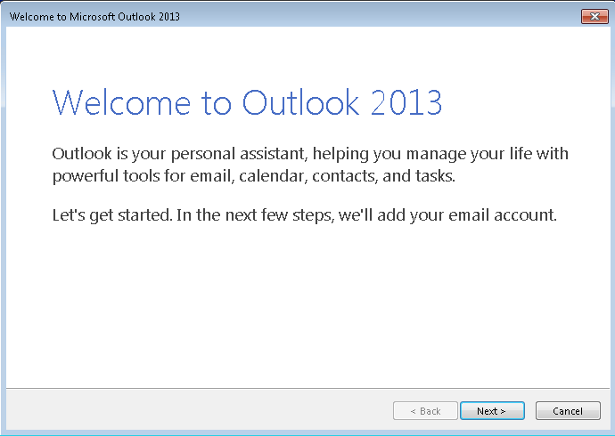

1. The next window asks you to confirm that you want to set up an account. Make sure the Yes option is highlighted and click Next.  
     
   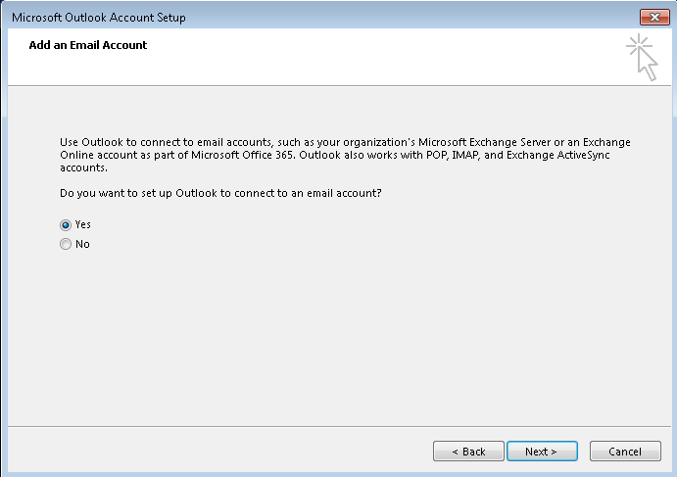
2. The Add New Email Account screen is displayed. Your name and email address should be filled in by default. If your name is not automatically filled in, add your email address in the Email address field. Your email address is your username with @cegep-heritage.qc.ca added to it.

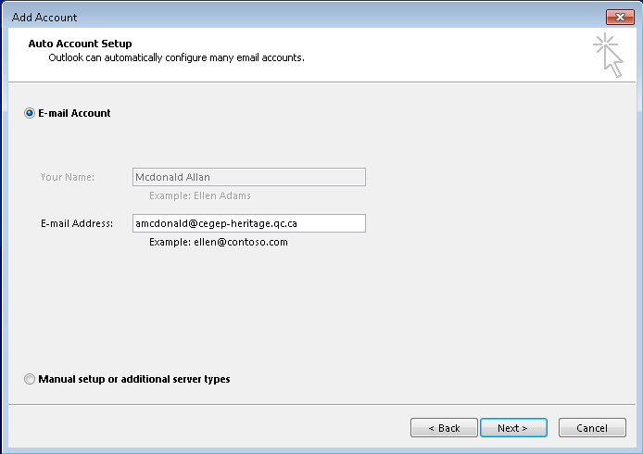

1. Click **Next**. Your email account should be successfully set up now:

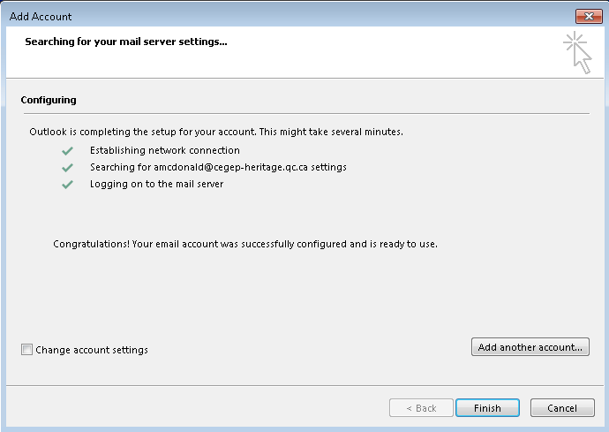

**If you do NOT receive the above screen, let me know immediately. Do NOT click finish. We may have to set up your account manually.**

1. Click **Finish**. Outlook 2013 will now open.

***Note***: You have set up your profile on the desktop computer. The next time you use this computer, simply open Outlook and your profile will be selected.   
  
If you use another computer, you will have to repeat this procedure to set up your profile there.

**Part C - Calendar Set Up**

1. In Outlook, select **Calendar** from the bottom Task Bar and change the view to be **Week** or **Work Week** by selecting the tab above the dates (See Figure 1).
2. Set up your timetable by repeating the following steps for each course block in your timetable.
   1. Starting with Monday, January 18 (today), select a block of time that corresponds to a course and then select **New Appointment** on the shortcut menu (See Figure 1).

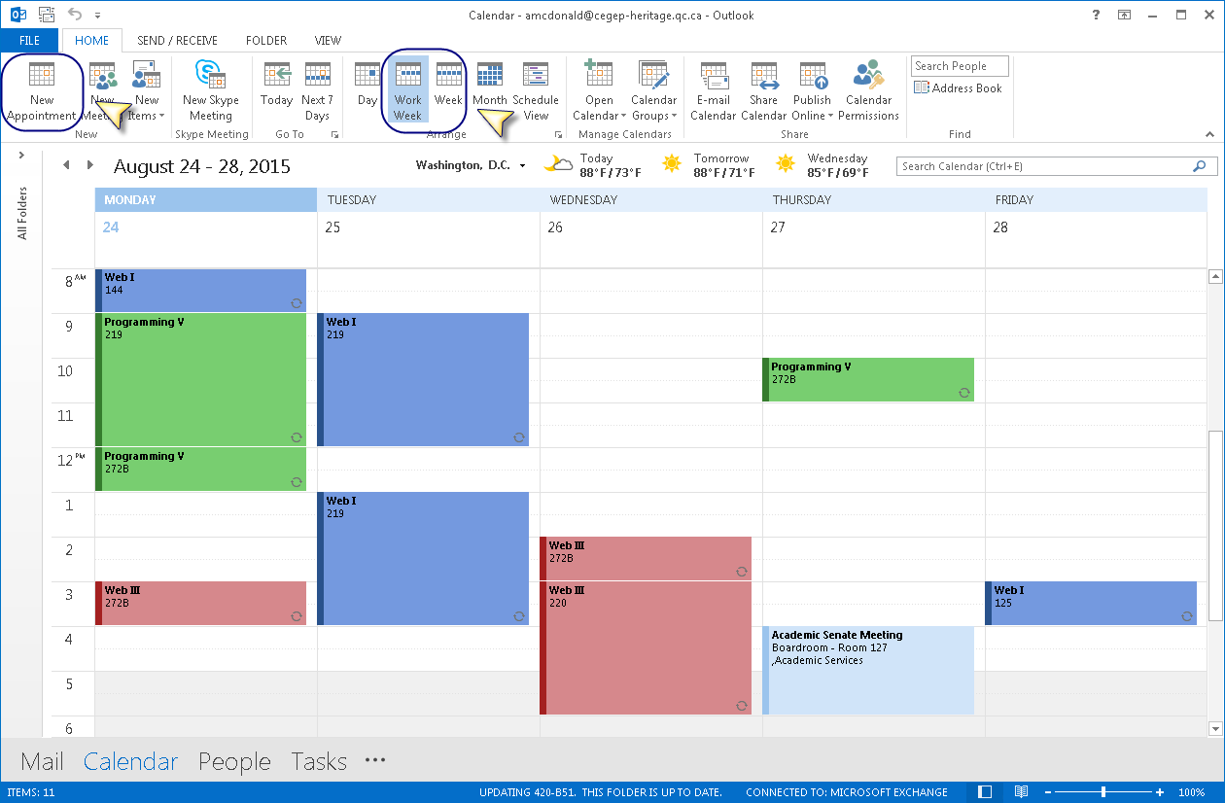

Figure 1: Calendar Page

* 1. Ensure that the Appointment is set up as follows:
     1. In the **Subject** box, type the name of the course. In the **Location** box, enter the room number.
     2. The Start and End time should be the starting hour and ending hour for the block in your timetable. The end time should **not** be changed to be 10 minutes before the hour. The Duration is automatically calculated.
     3. Set the Reminder for the entry to be None.
     4. Press the Recurrence button to set up repeats

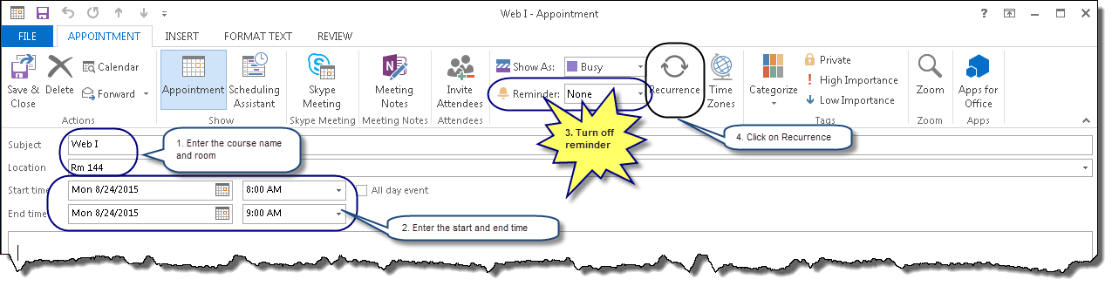

Figure 2: New Appointment

* 1. Set the recurrence to weekly with the appropriate day checked.
     1. Set the **Range of recurrence** to **End by:** May 10, 2016. Click **OK** (see Figure 3).

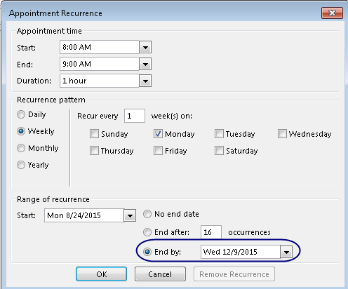

Figure 3: Recurrence Pattern

* 1. Colour-code your courses:
     1. Select the Categorize icon from the toolbox at the top.
     2. Find the Category matching the course and select the checkbox next to it to assign it to the current calendar entry.
     3. Create a different colour category for each course as in Figure 4.

If this is the first entry, you will have to set up the categories for your courses. To do this:

* + 1. Select the Categorize Dropdown.
    2. Select **All Categories…**
    3. Follow the steps to create your categories.

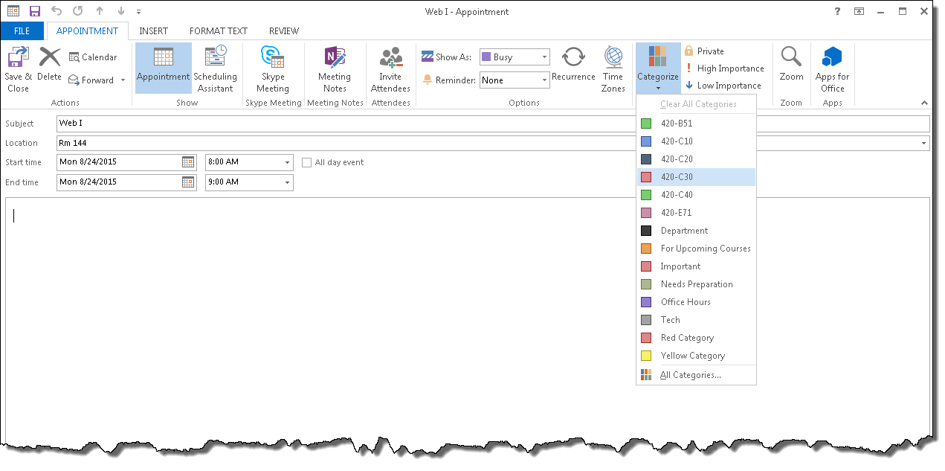

Figure 4: Colour Coding Courses

* 1. When the entry is complete, with recurrence set and colour coding complete, click **Save and Close**.

1. A copy of the Academic Calendar is linked to the lab in Moodle. Open the document now to complete the next section. Change your Outlook calendar to match the academic calendar as follows:
   1. Delete the occurrences during the study days and mid-term holiday (February 29-March 3) by selecting each block on that day and Deleting them either by clicking the X button in the menu bar or pressing the Delete button on your keyboard. Make sure that **Delete this occurrence** is selected when prompted.

### Delete the occurrences on Easter Monday, March 28 by selecting each block on that day and Deleting them either by clicking the X button in the menu bar or pressing the Delete button on your keyboard. Make sure that **Delete this occurrence** is selected when prompted.

### Delete the occurrences on Tuesday March 22, by selecting each block on that day, selecting Delete from the shortcut menu, and ensuring that **Delete this occurrence** is selected. Giv

### Move the occurrences from Good Friday, March 25 to Tuesday, March 22 by double clicking each appointment and changing the date. Make sure that **This occurrence** is selected. You can also drag and drop the occurrence to the new day.

1. While viewing your calendar, make sure that the Home click on the Share Calendar button on the menu bar. See below.

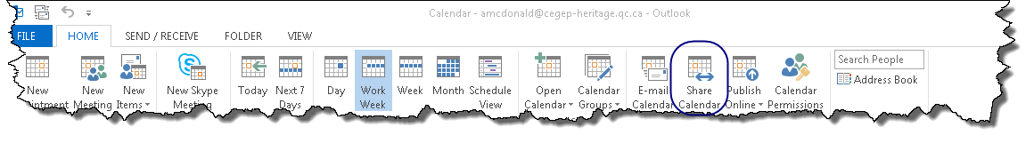

Figure 5: Sharing the Calendar

1. When prompted, specify that you share your calendar with the user **#Teaching Staff Computer Sciences** (all the Computer Science teachers). This will allow teachers to view your calendar. Make sure you specify Full Details in the Details drop down. See below.

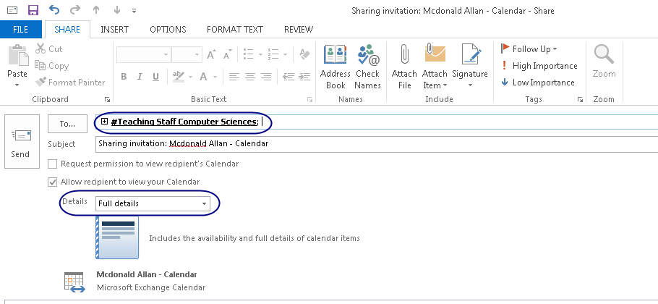

Figure 6: Sharing details

**Part D – Rules in Outlook**

Purpose: The purpose of this section of the lab is to set up a rule to direct all mail that is sent to all students to a subfolder so that your email inbox contains only mail directed to you specifically.

If you did this last term, then there is nothing to do here, but you should check.

1. Start Web mail in Internet Explorer. (This only works in IE. The option isn't available in other browsers.)   
   (You can also do this in the desktop version of Outlook, but since you will likely be accessing your college mail through webmail most of the time, this will give you some practice using this version)
2. Click the gear in the upper right hand corner of the web page and choose Options.  
    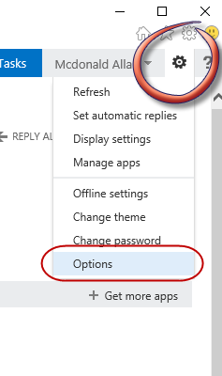
3. Select “organize email” from the navigation pane on the left. “inbox rules’ should be selected, if not select it.

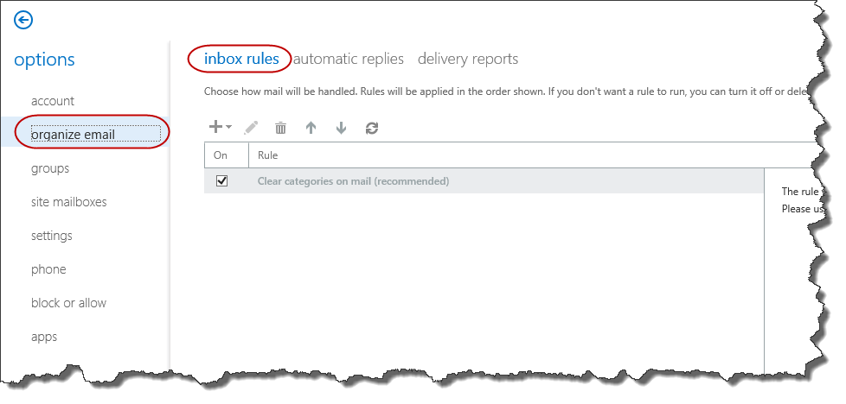

1. Select the Plus sign to add a rule. Select “Move messages sent to a group to a folder…” from the New Rule dropdown list.

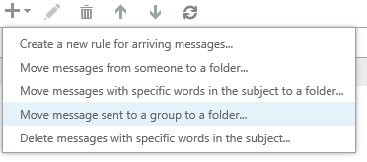

1. Give the rule the name “RemoveAllStudent” and use the Select people link to choose ##Heritage Students from the list.
2. Click the “Select one” link next to the Move the message to folder. When the Pop is displayed create a new folder and call it All Students.
3. When you click Okay the new rule form looks like this:

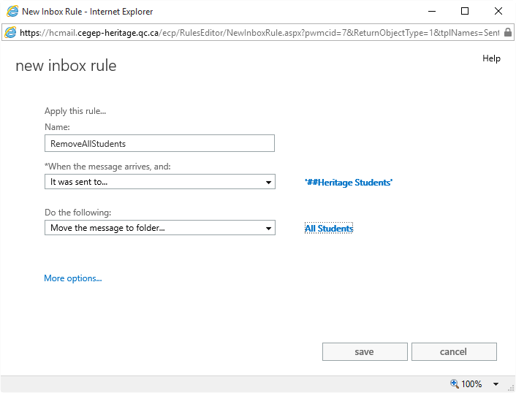

1. Click Save and then the Arrow to return to your Inbox. Any future messages sent to Heritage Students will now be moved to this folder. You can do other things such as delete these messages if you want.
2. Now you will only have messages that come to you of your class in your inbox. This will make it much easier to find your marked labs and assignments in your email.

**Part E – Moodle Quiz**

* 1. Complete the Moodle quiz for today’s lab.

**Part F – CSS Forms Review**

1. Start Dreamweaver and create a new site called C20_L01A. Store the site in the folder H:\420-C20\Labs \YourUserName_C20_L01\partF
2. All CSS formatting characteristics must be kept in a file called forms.css in the styles subfolder of your website.
3. Create a new file called feedback.html. This will be a file with a header (h1) and a form. The various elements on the page and form (including things like the title) are detailed in the image below. Use this image to create the form. Some basic CSS is provided on the image, but other CSS is detailed following the form. Note: You may want to zoom in on the document to read the instructions on the form more easily.
4. The form has the following characteristics:
   1. Is called fback
   2. Uses the get method;
   3. Has an action to open the page response.html.

NOTE: the <h1> is outside the form.

1. There is a CSS rule such that all legends on the page:
   1. use a font-size of .9em;
   2. have a line-height of 20px;
   3. are bolded
   4. Have a text colour of black (#000)
2. Add a CSS rule such that all fieldsets on the page:
   1. Have a left and right margin of 155 pixels
   2. Have a solid border 1 pixel wide, in black
   3. as rounded corners with a radius of 10 pixels (Remember to accommodate all browsers (and chrome))
3. Create a class called textlabel with the following characteristics:
   1. line-height: 20px;
   2. text-align: right;
   3. width: 150px;
   4. margin-right: 5px;
   5. float:left;
   6. font-weight:bold;
   7. font-size: .9 em;

Attach the textlabel class to each of the **text box/text area** labels on the form below.

1. Create a class called checklabel with the following characteristics:
   1. line-height: 20px;
   2. font-weight:bold;
   3. font-size: .9 em;

Attach the checklabel class to each of the **check box** and **radio button** labels on the form.

1. Create a class called buttoncss with the following characteristics:
   1. A left margin of 155 pixels

Attach the buttoncss class to the **button** on the form

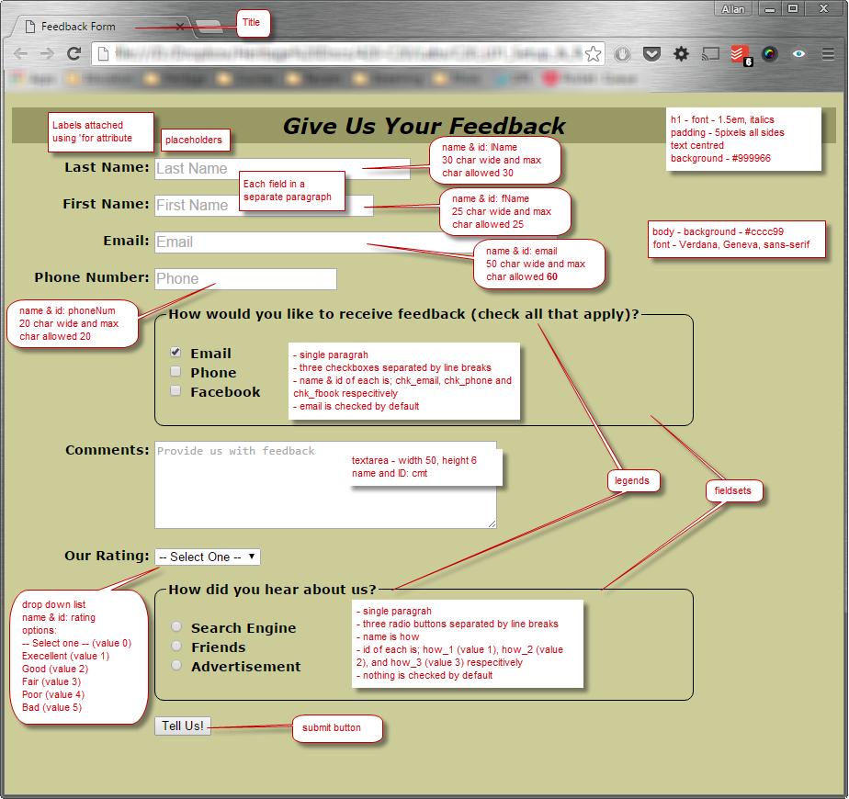

1. Completed form is looks like the one below:

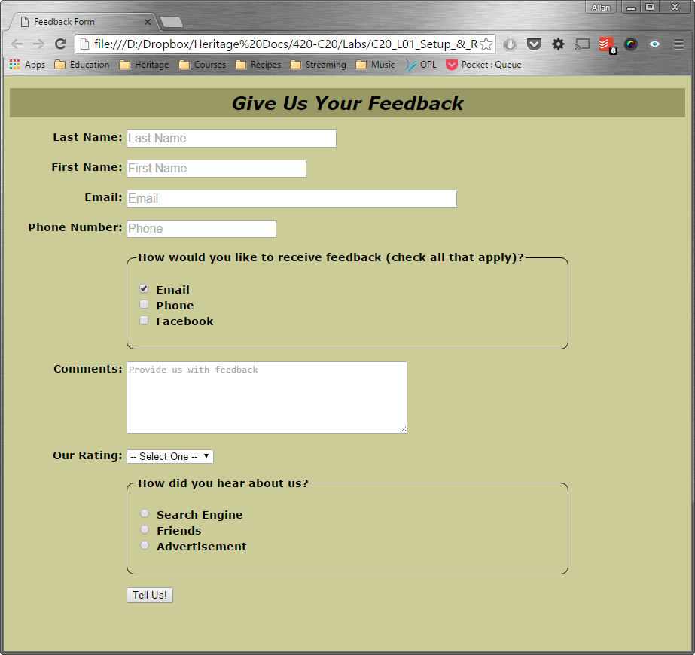

Figure 1: Initial Feedback Form

1. Create a new HTML file with the name response.html, the title ‘Feedback Response’ and link the forms.css CSS file to it.
2. Add the following to the file response.html:
   1. A first level header with the words Feedback Response
   2. A paragraph with: “We value all customers' opinions and want you to know that your comments will be addressed as soon as possible.”
   3. A second paragraph with: “Please visit us again soon.”
3. Include a horizontal rule as the next line in the html file
4. Add an unordered list with square bullets to the document with the following list elements:
   1. Try our online reservation program
   2. Try our new JavaScript tutorial
   3. Try our new temporary exhibit page
5. Display the feedback form, enter some data and submit the form. The response form should look like this:

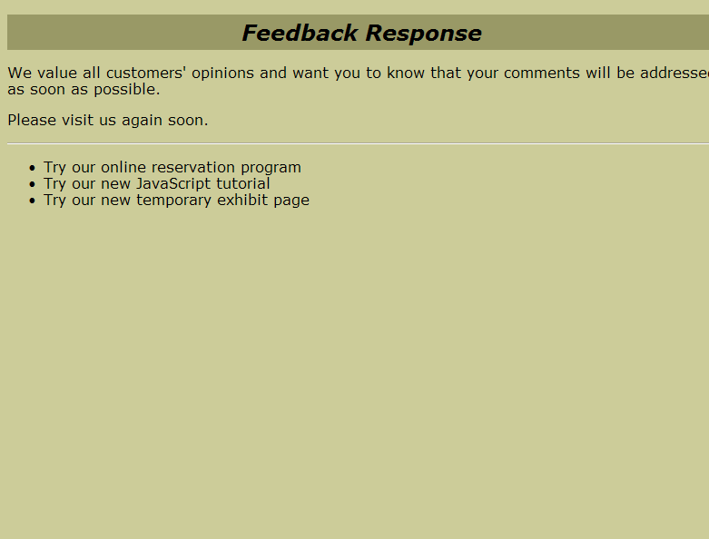

Figure 2: Initial Response Form

1. Make sure that you validate both the CSS and both the HTML files.

**Part G – Responsive Web Design**

1. Start Dreamweaver and create a new site called C20_L01F. Point the site to the folder H:\420-C20\Labs \YourUserName_C20_L01\partG that you created during the Lab Setup step above.
2. Open the file rwd.html. You are going to add a CSS file with media queries to display it for different device sizes. Take a look at the file and notice the following:
   1. The ids of the divs in the files (wrapper, banner, nav and content).
   2. The fact the second and third list items in the nav div have the class notmobile.
3. Start by creating a CSS file called rwd.css in the styles subfolder and attaching it to the rwd,html file.
4. Add rules as follows:
   1. The body has a background colour of: #B7FFB7.
   2. The wrapper div has the width set to auto.
   3. The banner div has the background colour #060 and the font colour of #efefef.
   4. The h1 element has the font size of 1 em, uses the font-family: Tahoma, Geneva, sans-serif and has the text aligned to the centre.
   5. Add a nav div so with the background colour is #00D200, a padding of 2px top and bottom and 0 pixels left and right and uses the font family Verdana. Geneva, sans-serif.
   6. Add properties for the list items in the unordered list in the nav div to have a thick, solid border of the colour #fff, displays inline, has no list style type, has a font colour #003c00 and padding of 4 pixels top and bottom and 8 pixels left and right.
   7. Add a class called notmobile which has a display: none with the additional property of !important.
   8. Add an id of content with the background colour of #060, no padding, uses the font family Verdana. Geneva, sans-serif, and has a font size of 1.2 that of an uppercase M.
5. The completed page should look like this:

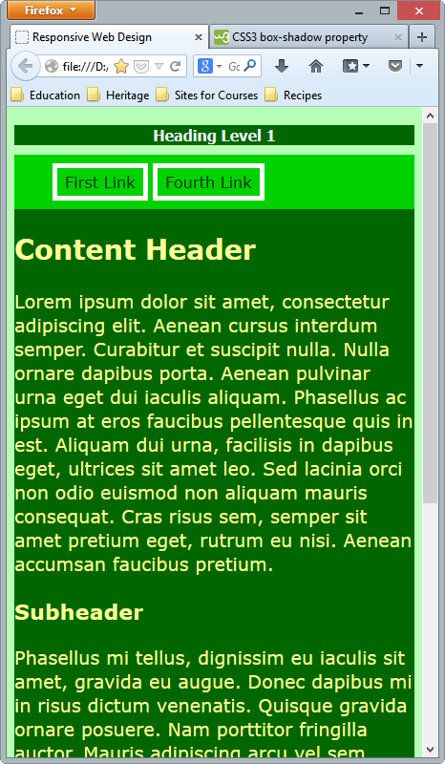

1. Add a media query to the bottom of the CSS file for all devices with a minimum width of 700px. All of the following CSS properties must be set within this media query (only include the properties listed in the media query; do NOT add any others):
   1. The body has a background colour of #D5DDFF.
   2. The id banner has a background colour of #271450 and a font colour of #9cf
   3. The h1 element is going to change to use the font family ‘Italianno’, cursive, has a font size of 2em and a text shadow of 4px to the right, 4 px down, 4 px wide in the colour #AAA. Note, the quotes around ‘Italianno’ are required.
      1. The font ‘Italianno’ is not available on the computer, but is available over the internet from Google. To use the Google font set ‘Italianno’ you must include the link to the Google font api BEFORE any other links in your page, so, in rwd.html, before linking the rwd.css file include the following link element:  
         <link href='http://fonts.googleapis.com/css?family=Italianno' rel='stylesheet' type='text/css'>
   4. The nav id which has the background colour property of inherit. This means that the background colour will be inherited from its parent element.
   5. The list items in the unordered list in the nav div to have a padding of 4px on all sides, use the font colour #1f1f1f and have a thin, solid border of colour #000.
   6. The class notmobile has a display: inline with the additional property of !important.
   7. The id content has the background #006, the font colour is #ff9, a width of 100% and padding on the right of 5px.
2. The completed page should look like this when the browser is wider than 700px and like the first image when the browser is more than 700px:

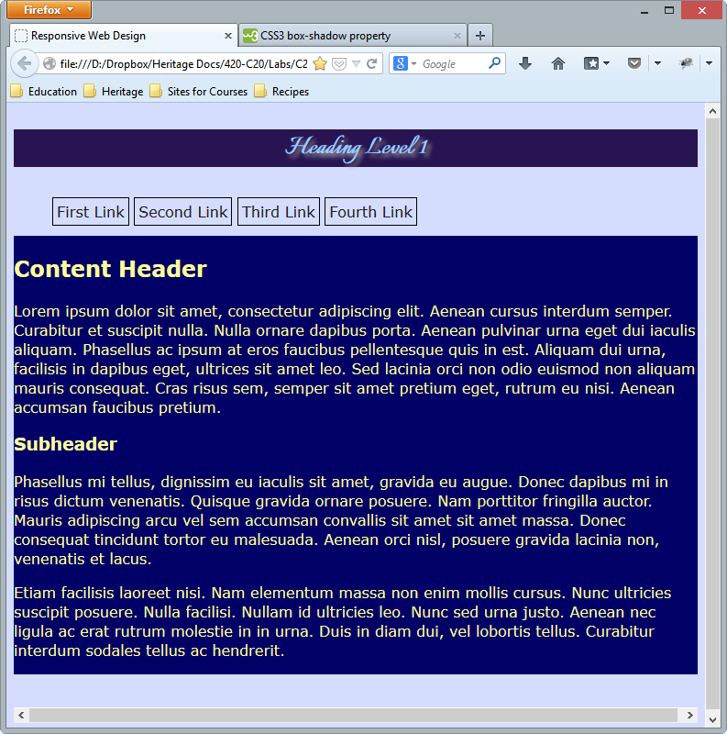

1. Add a second media query to the bottom of the CSS file (below the end of the last media query) for all devices with a minimum width of 1000px. All of the following CSS properties must be set within this media query (only include the properties listed in the media query; do NOT add any others):
   1. The body has a background colour of #aaa;
   2. The wrapper div:
      1. Has 90% width
      2. Is centred from the left and right (ONLY)
      3. Uses the background image bg.jpg in the images folder
      4. Automatically overflows the content
   3. The banner div:
      1. Has a background colour of c9c9c9
      2. Has a text colour of 333
   4. The h1 element:
      1. Has a font size of 4em
   5. The navigation (nav) div:
      1. Has a padding top and bottom of 0 and a padding left and right of 2 px
      2. Floats to the left of the screen
      3. Has a width of 10 widths of the letter M
   6. The list items in the unordered list that is part of the nav div:
      1. Has the text aligned to the centre of the div
      2. Has a padding of 2px on all sides
      3. Is displayed as a block
   7. The class notmobile has a display: block with the additional property of !important.
   8. The content div:
      1. Has a background colour of eee
      2. Floats to the left
      3. Has a width of 80%
      4. Inherits the font family from its parent (font-family inherit)
2. The completed page should look like this when the browser is wider than 1000px, like the second image between 700 and 999px and like the first image when less than 700px:

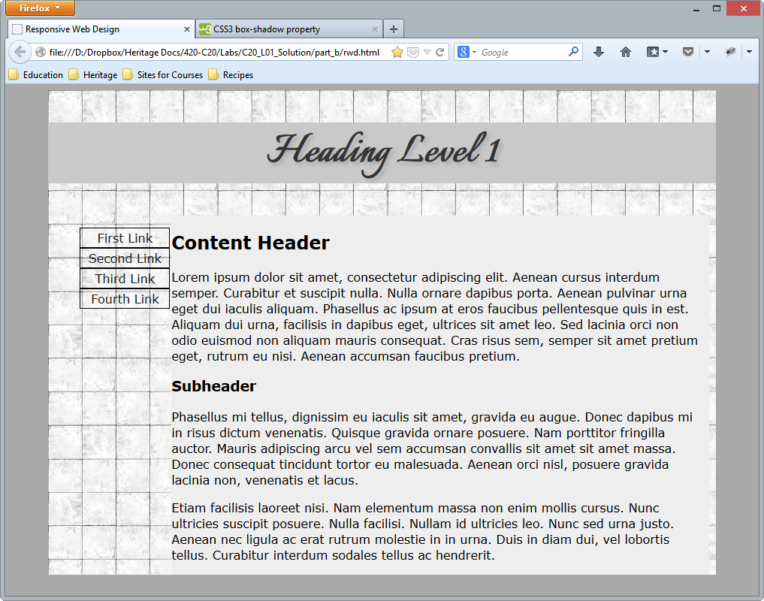

**To submit**

When you have completed the lab exercise call me over and we will review it/mark it together. You will also need to zip the file and copy it to Moodle.